Vol. 52 No… 8 Upcoming Events!

August 2 – Youth will go to Hawaiian Falls waterpark in The Colony. Meet at the church building @ 9:00 a.m.

August 3 – First Sunday Fellowship immediately following morning services. Bring your favorite foods & join in the fun! Evening services will be at 1:00.

August 17 – Elders & Deacons meeting at 3:30 p.m. If you have anything to discuss let them know.

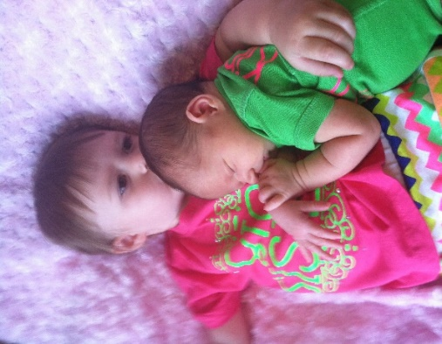

Kaydence Perry proudly announces the arrival of her baby sister, Kinlyn Grace, who was born July 8, 2014, weighed 8 lbs., 3 oz., & was 21” long. Proud parents are Korey & Jessica!

ATTN: ALL YOUTH
On Sun., Aug. 3rd, following our afternoon service, there will be a “surprise” project to be done, followed by bowling, Pizza & a devo. Bring an old shirt that can be ruined & $$ for pizza & bowling!

Scripture Reading Plan for August 2014

August 1 John 1, 1, 2
August 4 John 1, 2, 3
August 5 John 2, 3, 4
August 6 John 3, 4, 5
August 7 John 4, 5, 6
August 8 John 5, 6, 7
August 11 John 6, 7, 8
August 12 John 7, 8, 9
August 13 John 8, 9, 10
August 14 John 9, 10, 11
August 15 John 10, 11, 12
August 18 John 11, 12, 13
August 19 John 12, 13, 14
August 20 John 13, 14, 15
August 21 John 14, 15, 16
August 22 John 15, 16, 17
August 25 John 16, 17, 18
August 26 John 17, 18, 19
August 27 John 18, 19, 20
August 28 John 19, 20, 21
August 29 John 20, 21, 21

Questions:
- According to John chapter 1, who came as a witness to testify so that all men might believe?
- Who was Nicodemus?
- Who did the chief priests and Pharisees send to arrest Jesus?
- By the time Jesus reached Bethany how long had Lazarus been in the tomb?
- What command does Jesus give in John chapter 15?
- What did Jesus say the disciples would have in the world?
- What was the name of the high priest's servant whose ear Peter cut off?
- What did Jesus do that was NOT recorded in the book?
- Counting through John chapter 21, how many times did Jesus appear to his disciples after he was raised from the dead?

August 2014

Sunday Morning | 3 | 10 | 17 | 24 | 31
Scripture | SEE | NOLAN | BUTLER !
Read by | Hunter Grose | Ken Robbins | Paul Payne | Tyler Carter | Bradley Cochran
Opening Prayer | Charlie Thompson | Charlie Hodgkiss | Robert Ballard | Rick Zant | Sheradon Carter
Song Leader | Sheradon Carter | Wylie Dykes | Bobby Graves | Charlie Hodgkiss | Paul Payne
Announcements | Rick Zant | Michael Fry | Bobby Graves | Rick Zant | Michael Fry
Lord’s Supper | Eddie Elmore
 | Chesley Phillips
 | Craig Zant
 | Billy Fergurson
 | Phillip Norman
 | Dalton Phillips
Closing Prayer | Travis Ball | Edd Fry | Chris Mathews | David Welch | Tim Parks
Usher | John Nash
Comm. Prep. | Chesley & Dana Phillips
Sound Board | Warren Skeen
Sunday Evening | 3 | 10 | 17 | 24 | 31
Opening Prayer | J.R. Butler | Michael Fry | Wylie Dykes | Billy Fergurson | Eldon Eudy
Closing Prayer | Chad Graves | Eddie Don Pickering | Stephen Arnold | Dudley Zant | Junior Oliver
Wednesday | 6 | 13 | 20 | 27
Devotional | Paul Payne | Rick Zant | Bobby Graves | Warren Skeen

Please remember these in your prayers: Cristy Brazeal, Lola Purser, our brethren in Mexico, Thelma McDowra, Nina Campbell, Mildred Rodgers, Tracy Martinez, April Good, Travis Palmer, James Carter, Micah, Jennifer & Gus Fry, Thomas & Jean McGee, teachers & students as they return to school, Stormi O’Briant (Dudley Zant’s granddaughter), Sherry Clarkson, Shannon Kyle, David Brown, Joe Carpenter, Sheila Icenhower, Billy Cavender, Nick Becerra.

periodical

College Caller (USPS 852-240) is published monthly by the College church of Christ, P.O. Box 1426, Paris, TX 75461. Periodical postage paid at Paris, TX 75460 Postmaster: Send form 3579 to the College Caller, P.O. Box 1426 Paris, TX 75461.

August Birthdays

1 – Cristi Burnett
7 – Patti Murray
8 – Travis Ball
9 – Betty Eudy
11 – Jill Hodgkiss
12 – Cindy Dykes
13 – Chance Booker
14 – Haven Shelton
16 – Sherry Kyle
18 – Ryan Pickering
19 – Charlott Pickering
20 – Edd Fry
21 – Joyce Oliver
21 – Alyssa Parks
22 – Jay Dykes
25 – Jason Brown
25 – Pam Fry
27 – Janice Cochran

August Anniversaries

8 – Mark & Tawana Stewart
14 – Jay & Britni Dykes
24 – Nick & Sally Becerra
27 – Brad & Janice Cochran

Sunday Bible Study 9:00 am
Worship 10:00 am
Worship 5:00 pm
KPLT Radio Program 96.3 FM 9:00 am

Wednesday
Bible Study 6:00 pm

Elders Michael Fry 732-5182
Bobby Graves 785-7089
Rick Zant 785-2381
Website: www.collegechurchofchristparis.com
College Caller
A bulletin of the College church of Christ
1030 24th SE, Paris, TX 75460 (903) 785-2170
August 2014
ATTENTION…
SAVE THE DATE!

November 1-2, 2014
For the
60th Anniversary Celebration of

College church of Christ
1030-24th S.E.
Paris, TX 75460

The celebration will begin Sat., Nov. 1st, with refreshments & an opportunity for former & current members to visit beginning at 4:00 p.m. There will be congregational singing and the acapella group, “His Harmony”, will perform at 6:30 p.m. at the church building.
On Sun., Nov. 2nd, we will have a special children’s Bible Class at 9:00 a.m., an adult Bible Class of “Remember When” & worship service at 10:00 a.m. with Jerry Lawlis, a former preacher here, speaking. Humberto Hernandez, missionary who introduced us to the work in Mexico, will speak at the 1:00 p.m. service.

