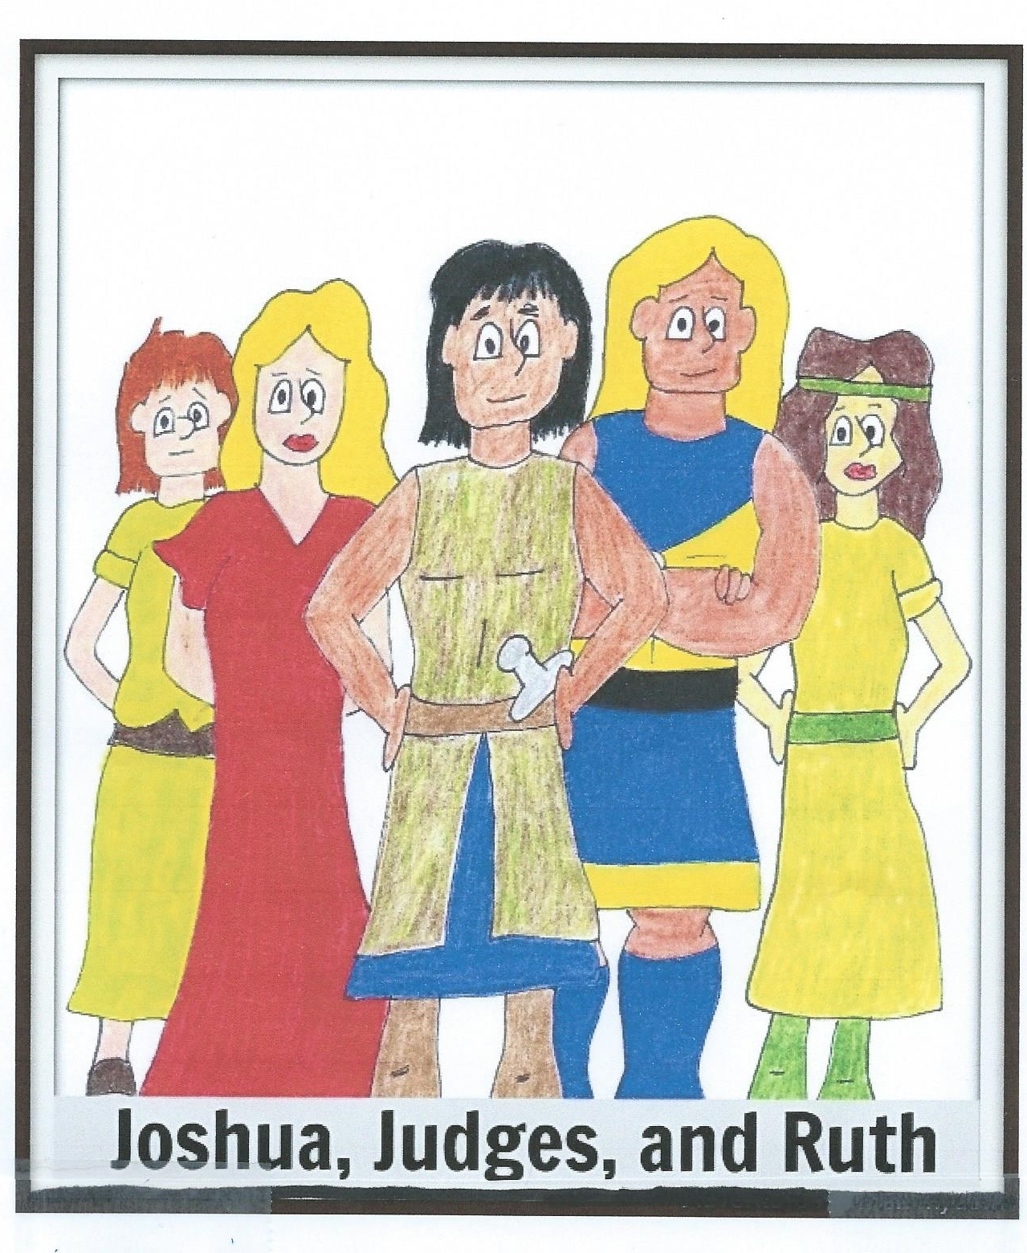
VACATION BIBLE SCHOOL
For ages 2 yrs. – 5th graders

Join us on
Sat., June 13, 2015, 9:00 a.m.-2:00 p.m., at
College church of Christ
1030-24th S.E.
Paris, TX
Lunch & snacks will be provided!

