

**Saturday, June 11, 2016**

**For Ages 2 yrs. thru 5th Grade**

**9:00 a.m. -2:00 p.m.**

**College church of Christ**

**1030-24th S.E., Paris, TX**

**10**

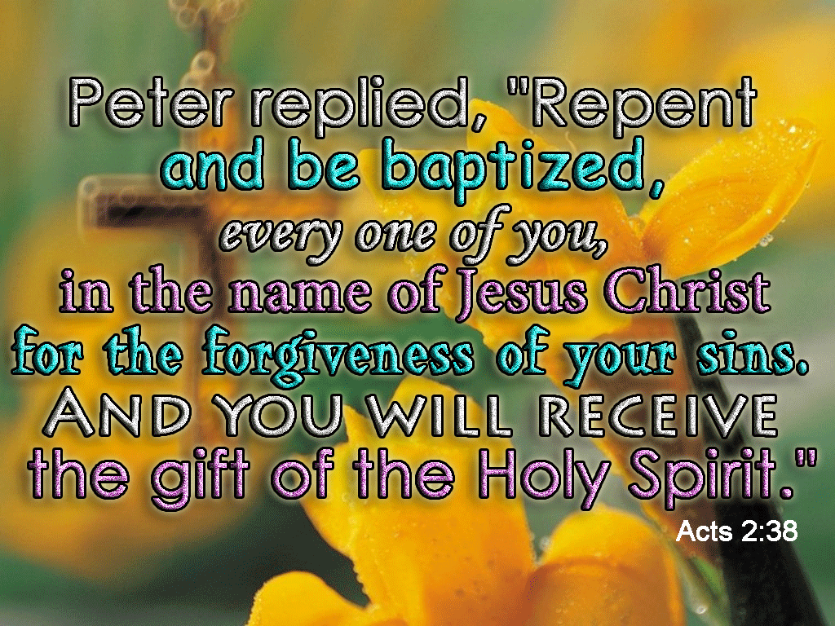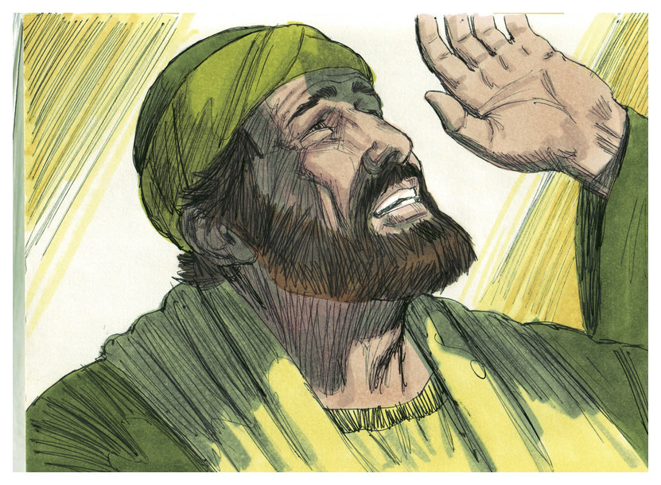

**Join us as we study lessons from the Book of Acts**

Lunch & snacks provided